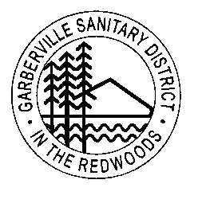 **Garberville Sanitary District**

**PO Box 211**

**919 Redwood dr.**

**Garberville, CA. 95542**

**Office(707)923-9566 Fax(707)923-3130**

**PRESS RELEASE STATEMENT**

On Tuesday September 24th 2024, The Garberville Sanitary District met for their regular Board Meeting and this press release is the highlights of that meeting.

TOPICS OF DISCUSSION

1. There was a presentation about the possibility of switching to “smart water meters”, which would provide minute by minute water use data and integrate the information into our customer accounting system. The disadvantages are that there is a large cost to purchase the meters, which does not include installation.

We will continue looking at this possibility.

1. The District is developing a Code of Conduct policy which will be on our website, in the office and in our ordinance. This policy will clearly state what is expected from employee, vendor, community and contractor interaction.
2. GSD is updating the “Late Payment” ordinance in order to address late payments and the process which will take place when payments are late.

---------------------------------------------------------------------------------------------------------------

Garberville Sanitary District is very appreciative of the relationship we have with our customers and community because your input assist’s us in making decisions which help all of us.