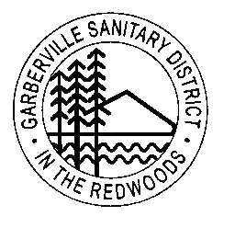 **Garberville Sanitary District**

**PO Box 211**

**919 Redwood DR.**

**Garberville, CA. 95542**

**Office(707)923-9566 Fax(707)923-3130**

**Sec 9.7 Customer’s Guarantee.** The water charge begins when a service connection is installed and the meter is set. The property owner must sign the customer service agreement form prior to being connected. This agreement guarantees that the owner is responsible for their property and for all unpaid service charges.

1. Customers are required to place a deposit of ($200), refundable or applied to account after 2 years of good payment history.
2. Owner will be responsible for any unpaid charges. Account must be current before customer’s account can be established.
3. Failure to receive a bill does not relieve consumer of liability. Any amount due shall be deemed a debt to the District and any person, firm, or corporation failing, neglecting, or

refusing to pay said indebtedness shall be liable to an action in the name of the District in any court of competent jurisdiction for the amount.